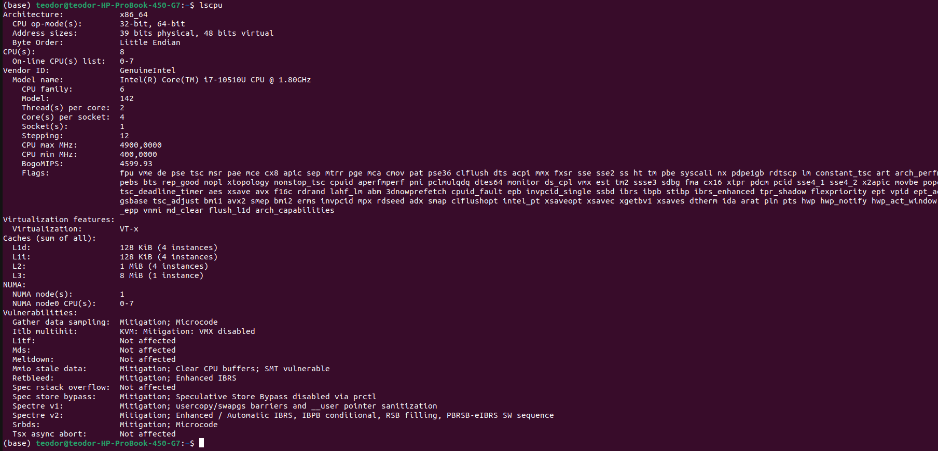
Practic 1

1. Number of cores
4 cores per socket. 1 socket → 4 cores
2. Cache memory
L1d(Data) Cache:
Size: 128 KIB
Instances: 4
L1i (Instruction) Cache
Size: 128 KIB
Instances: 4
L2 Cache:
Size: 1 MIB
Instances: 4
L3 Cache:
Size: 8 MIB
Instances: 1

3. Explanation for Multiple Instances of Caches:
-Each core in the CPU has its own L1d (data) and L1i (instruction) caches. In this case, there are 4 instances of each, indicating that each of the 4 cores has its own separate L1 caches
- The L2 cache is shared among the cores, and there are 4 instances, which means each core has access to a portion of the shared L2 cache
- The L3 cache is a larger cache that is common to all cores. In this case, there is 1 instance of the L3 cache shared among all 4 cores

Having multiple instances of smaller caches closer to each core helps in reducing latency for frequently accessed data. The shared larger cache (L3) facilitates data sharing among the cores and helps improve overall system performance.

Practic 2
1. See MatricesSolved.h
You can compile it with:
g++ -o Matrices_Solved Matrices_Solved.cpp Timer.cpp
./Matrices_Solved

2. To compute both the minimum and maximum values in a single pass through the array, I modified the TestFindMinAndMax function and created a single function that returns both values. This way, I avoided iterating through the array twice.

See MinMaxSolved

3. See StructsModified.h
When I ran the program I used the top -p <pid> command (after compiling it with g++ -o struct_optimization structsp.cpp Timer.cpp and running ./struct_optimization) and saw some differences. We have to keep in mind, though, that the struct optimizaton may vary depending on the compiler architecture

4. See StructsTwoModified.cpp and StructsTwoModified.h files for the new implementation

